VISION FOR AFRICA PRIMARY SCHOOL

KIYUNGA EXAMINATIONN BOARD SST P.6 END

OF TERM II 2024

NAME……………………………………………………… STREAM …….......

SCHOOL……………………………………………………………………………

DISTRICT………………………………………………………………………….

1.What social service is provided by teachers in school

……………………………………………………………………………………….

2.Name any one type of weather which encourage one to use umbrellas

…………………………………………………………………………………….

3.What name is given to a drawing of an object as seen from above?

……………………………………………………………………………………….

4.Name the feature that enables motorists to cross the drainage like rivers

……………………………………………………………………………………….

5.How is river Nile promoting industrial development in Uganda?

………………………………………………………………………………………………………………………………………………………………………………

6.Name the type of wood obtained from natural forests

……………………………………………………………………………………….

7.Why is the dry season the best for harvesting cereals

………………………………………………………………………………………………………………………………………………………………………………

8.Give any one product that is manufactured using limestone.

…………………………………………………………………………………….

9.State any one way in which the Uganda police enforces the law and order.

……………………………………………………………………………………………………………………………………………………………………………….

10.What term is used to mean a group of people living together?

……………………………………………………………………………………

11.Draw a map, symbol for a contour in the space below.

|  |
| --- |
|  |

12.Why did early man live a settled life after the discovery of farming?

……………………………………………………………………………………………………………………………………………………………………………….

13.Give one service of East African Community which remained operating in Uganda after is collapse in 1977

……………………………………………………………………………………………………………………………………………………………………………...

14.Name the river that forms the natural boundary between Tanzania and Mozambique.

……………………………………………………………………………………..

15.Mention the body which is responsible for maintaining the major roads in Uganda.

……………………………………………………………………………………………………………………………………………………………………………….

16.Why is land considered to be the most important resource?

……………………………………………………………………………………………………………………………………………………………………………….

17.Name the tourist attraction found in Nyero archaeological site.

…………………………………………………………………………………….

18Why is air transport used by very few people in Uganda?

……………………………………………………………………………………………………………………………………………………………………………….

19Name the railway line that connects Zambia to Port Dar es Salaam at the coast of Tanzania.

………………………………………………………………………………………………………………………………………………………………………………

20.Why do pupils read newspapers at school?

………………………………………………………………………………………………………………………………………………………………………………

21.What is a by-election?

………………………………………………………………………………………………………………………………………………………………………………

22.What name was given to the law making body in Uganda during colonial period?

……………………………………………………………………………………………………………………………………………………………………………….

23.Name the chief mineral Ugandans obtain from lake Katwe.

………………………………………………………………………………………………………………………………………………………………………………

24.Give any one factor that determines population distribution in Uganda.

………………………………………………………………………………………………………………………………………………………………………………

25Write VAT in full.

………………………………………………………………………………………………………………………………………………………………………………

26.What did the raising of British flag in 1894 mean in Uganda?

………………………………………………………………………………………………………………………………………………………………………………

27.Why is lake Kyoga swampy?

………………………………………………………………………………………………………………………………………………………………………………

28.Which arm of Uganda government is responsible for implementing the law?

………………………………………………………………………………………………………………………………………………………………………………

29.Why has the government empowered the local councils in Uganda?

………………………………………………………………………………………………………………………………………………………………………………

30.Name the neighbouring country of Uganda which is greatly covered by equatorial rainforest.

……………………………………………………………………………………….

31.Mention any one problem facing the people in mountainous areas.

……………………………………………………………………………………………………………………………………………………...……………………….

32.Give any one characteristic of downwarped lakes.

………………………………………………………………………………………………………………………………………………………………………………

33.How is solar energy different from hydroelectricity?

………………………………………………………………………………………………………………………………………………………………………………

34.Why is I K Musazi greatly remembered in the history of Uganda?

………………………………………………………………………………………………………………………………………………………………………………

35.Which was the only Bantu Kingdom formed in Kenya?

………………………………………………………………………………………………………………………………………………………………………………

In each of the questions 36 to 40, answer Either the Christian or Islamic question but not both.no marks will be awarded to a pupil who attempts both alternatives on the same number.

36.Either.In which Town was Jesus born?

………………………………………………………………………………………

Or. In which Town was Prophet Muhammad born?

……………………………………………………………………………………….

37.Either.How long did God take to create the universe?

………………………………………………………………………………………

Or. How long did Allah take to create the universe?

……………………………………………………………………………………….

38Either.How did Adam and Eve failed to live in peace with God?

……………………………………………………………………………………………………………………………………………………………………………….

Or. How did Adam and Hawa failed to live in peace with Allah?

………………………………………………………………………………………………………………………………………………………………………………

39.Either.Who received ten commandments from God?

………………………………………………………………………………………

Or Who received the first revelation from Allah?

…………………………………………………………………………………….

40Either What term is given to any useful activity that involves the use of energy?

………………………………………………………………………………………………………………………………………………………………………………

Or What term is given to the teachings of Prophet Muhammad(PBUH)

……………………………………………………………………………………………………………………………………………………………………………….

SECTION B

Questions 41 to 55 carry four marks each

Study the sketch map of Uganda below and use it to answer the questions that follow

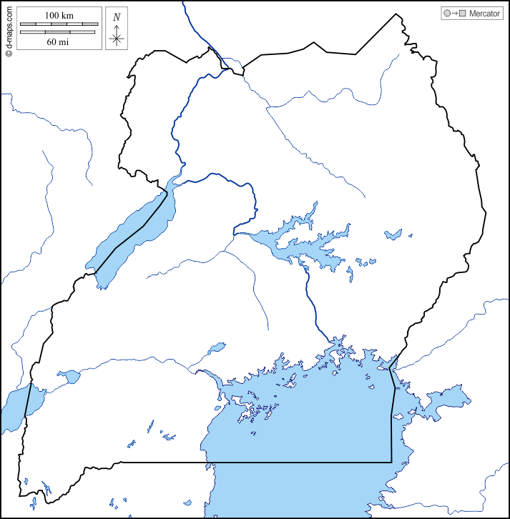

P

C

R

Q

r

a)Draw the line of equator on the map above.

b)Name the ethnic group that entered into Uganda using route labelled R.

………………………………………………………………………………………

c)How was the place marked P important in the migration of River Lake Nilotes?

………………………………………………………………………………………………………………………………………………………………………………

d)Why is mountain marked C snowcapped throughout the year?

………………………………………………………………………………………………………………………………………………………………………………

42a)What is natural vegetation?

………………………………………………………………………………………………………………………………………………………………………………………………………………………………………………………………………

b)Give any two reasons why we should plant trees in the school compound.

……………………………………………………………………………………………………………………………………………………………………………….

c)How does the fast growing population affect the vegetation of an area?

………………………………………………………………………………………………………………………………………………………………………………

43a)Give any two examples of mass media communicatio in East Africa.

………………………………………………………………………………………………………………………………………………………………………………

b)State any two advantages of using radio communication.

………………………………………………………………………………………………………………………………………………………………………………

44a)Apart from oil palm and cocoa.give any two traditional cash crop plantation in East Africa.

……………………………………………………………………………………………………………………………………………………………………………….

b)Give any two reasons why the British colonialists encouraged cash crop growing in Uganda.

………………………………………………………………………………………………………………………………………………………………………………

45Match the items in list A with list B correctly.

List A List B

Nyamwezi River Lake Nilotes

Iteso Bantu

Jaluo Highland Nilotes

Sabiny Plain Nilotes

(i)Nyamwezi………………………………………………………………………

(ii)Iteso…………………………………………………………………………….

(iii)Jaluo……………………………………………………………………………

(iv)Sabiny…………………………………………………………………………..

46a)Name any two invisible exports of Uganda.

……………………………………………………………………………………………………………………………………………………………………………….

b)Why is tourism called an industry?

……………………………………………………………………………………………………………………………………………………………………………….

c)Give any one problem facing the tourism industry in East Africa.

………………………………………………………………………………………………………………………………………………………………………………

47a)Give any two examples of renewable resources in East Africa.

……………………………………………………………………………………………………………………………………………………………………………….

b)State any two ways people have led to land degradation.

……………………………………………………………………………………………………………………………………………………………………………….

48a)Which organ of the East African Community carries out the day to day activities?

……………………………………………………………………………………………………………………………………………………………………………….

b)Mention two ways how the East African Community benefits its member states.

……………………………………………………………………………………………………………………………………………………………………………….

c)Outline one factor that contributed to the collapse of the East African Community in 1977.

……………………………………………………………………………………………………………………………………………………………………………….

49a)Name the group of foreigners that introduced the dairy farming in Kenya highlands.

……………………………………………………………………………………………………………………………………………………………………………….

b)Give two factors that encouraged the above group of people to start farming in Kenya.

c)Mention the main product obtained from a dairy farm.

……………………………………………………………………………………….

50a)Name the body responsible for collectiong taxes in Uganda.

……………………………………………………………………………………….

b)Mention any two examples of direct taxes collected in Uganda.

………………………………………………………………………………………………………………………………………………………………………………

c)Why is it important for Ugandans to pay taxes to the government?

……………………………………………………………………………………………………………………………………………………………………………….

………………………………………………………………………………………………………………………………………………………………………………

In each of the questions 51 to 55, answer Either or Islamic question but not both alternatives ian a number.No marks will be awarded t any pupil who atempts both number in the same alternatives.

51.Either (a)Give the collective name for the first five books in the bible.

…………………………………………………………………………………………….

b)Which is the five books talks about the creation?

………………………………………………………………………………………………..

c)From which early materia was man created according to the Bible?

………………………………………………………………………………………………….

d)Who wrote the five books youn have named in (a) above?

……………………………………………………………………………………………………

Or (a)Give the first surat in the Qur’an.

……………………………………………………………………………………………………..

b)Which Holy book in Islam was reveieved by Prophet Musa?

………………………………………………………………………………………………………

c)From which matetrial was man created according to the Qur’an?

………………………………………………………………………………………………………

d)Why did Allah create man?

……………………………………………………………………………………………............

52Either (a) Give any two reasons why Christian should work.

………………………………………………………………………………………………………………………………………………………………………………………………………………

b) State any two problems Christians face while working.

………………………………………………………………………………………………………………………………………………………………………………………………………………

Or What was Prophet Muhammad’s work before becoming a Prophet?

………………………………………………………………………………………………………

b)Why should a Muslim work?

………………………………………………………………………………………………………

c)Give any two problems Muslims face while at work.

………………………………………………………………………………………………………………………………………………………………………………………………………………

53Either (a) I will ask my Father and He will give you another helper(John 14:26)

(a) Who said the above words?

………………………………………………………………………………………………………

b)Who is refered to as the helper?

………………………………………………………………………………………………………

c)Give one signe to show that the apostles received the helper.

………………………………………………………………………………………………………

d)Why did Jesus promised the helper to His apostles?

………………………………………………………………………………………………………

Or (a)Name the first pillar of Islam.

……………………………………………………………………………………………………

b)Which pillar of Islam promotes the life of the needy?

……………………………………………………………………………………………………

c)State any two reasons why Muslims should observe the pillar of Islam.

………………………………………………………………………………………………………………………………………………………………………………………………………………

54Either(a)What is a prayer?

………………………………………………………………………………………………………………………………………………………………………………………………………………

b)Which prayer did Jesus taughtb His apostles?

……………………………………………………………………………………………………...

c)State any two requests made in the above mentioned type of prayer.

………………………………………………………………………………………………………………………………………………………………………………………………………………

Or (a)What is a prayer?

………………………………………………………………………………………………………………………………………………………………………………………………………………

b)State any three of the daily prayers said by Muslims.

………………………………………………………………………………………………………………………………………………………………………………………………………………………………………………………………………………………………………………………

55FOR BOTH (a)What name is given to the natural ability given by God/Allah?

………………………………………………………………………………………………………

b)Mention any two natural abilities given by God/Allah

………………………………………………………………………………………………………………………………………………………………………………………………………………

c)How can a person use such natural ability given by God/Allah to help those in need?

………………………………………………………………………………………………………………………………………………………………………………………………………………

E

E N D

D